**Lab 9 Notes**

Student ID: 22994257

Name: Gaoyuan Zhang

### [Step 1] Detecting Languages from text

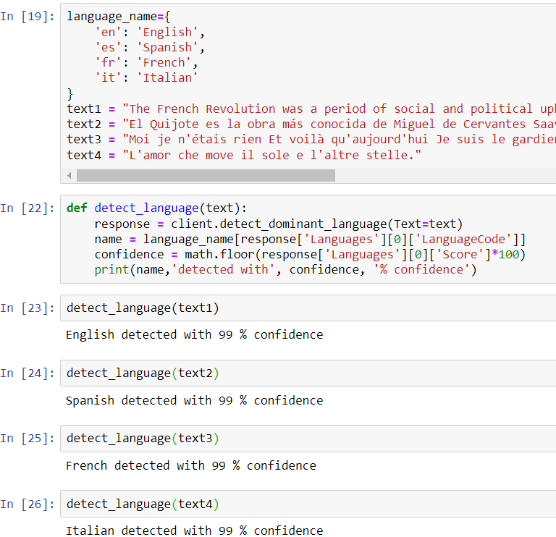

### [Step 2] Sentiment Analysis

### [Step 3] Repeat steps from [Step 2] for detecting entities.

Answer: In my words, entities are the real-world objects in a text, such as a person, location, organization, date and so on, which can be denoted with a proper name. The English word like ‘a’ ‘the’ can’t be an entity.

### [Step 4] Repeat steps from [Step 2] for detecting key phrases.

Answer: In my words, key phrases are some key noun phrases in one sentence, such as ‘The French Revolution’, ‘a period’ ,‘social and political upheaval’ and 'France'.

### [Step 5] Repeat steps from [Step 2] for detecting syntax.

**文本, 信件

**

Answer: In my words, the syntax tokens are all the tokens in the sentences and it will be classified with a tag, such as ‘ADJ’, ’NOUN’, ’ADV’, which means ‘adjective’ ‘noun’ and ‘adverb’.

### [Step 6] AWS Rekognition

1. Label Recognition

文本

表格

2. Image Moderation

3. Facial Analysis

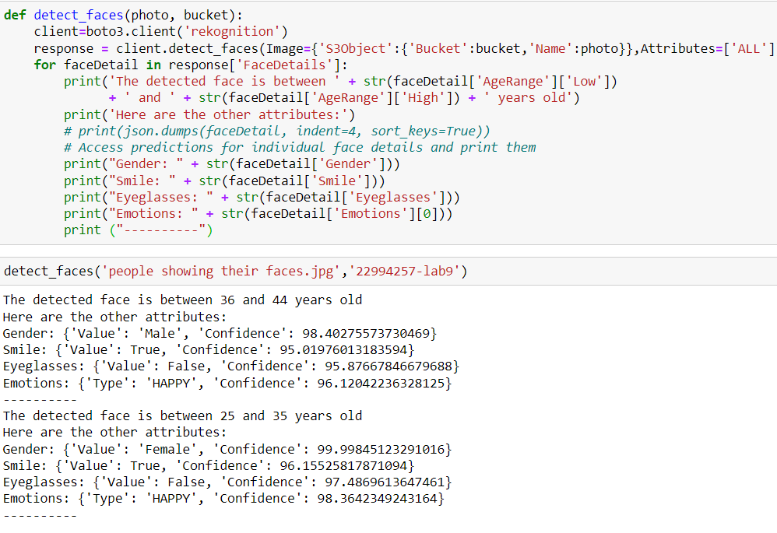

4. Detect Text from an image

文本

